**LAB CAT – 2**

**Internet and Web Programming**

**CSE3002**

**L55+L56**

**19BCE2141**

Q- Write a JavaScript and HTML program to get a string from user through HTML form. The given string should be reversed without using string reverse function when the user clicks the REVERSE button. The result will be displayed through a text box.

**HTML and JavaScript Code –**

<!DOCTYPE html>

<html lang="en">

<head>

<meta charset="UTF-8">

<meta http-equiv="X-UA-Compatible" content="IE=edge">

<meta name="viewport" content="width=device-width, initial-scale=1.0">

<title>LAB CAT 2</title>

<script>

function Reverse(){

var output = "";

var x=document.getElementById("reverse").value;

for(var i=x.length;i>0;i--)

{

output = output + x.charAt(i-1);

}

document.getElementById("final").value = output;

}

</script>

</head>

<body style="padding: 20px;">

<div style="margin: auto; width: 30%; border: solid black 1px; text-align: center; padding: 20px;">

<form>

<label for="reverse">Enter the String: </label>

<input type="text" id="reverse" name="reverse" value="">

<button type="button" value="reverse" onclick="Reverse()">REVERSE!</button><br><br>

<label for="reverse">Reverse of the String: </label>

<input type="text" id="final" name="final" value="" readonly>

</form>

</div>

</body>

</html>

**Output –**

Initially

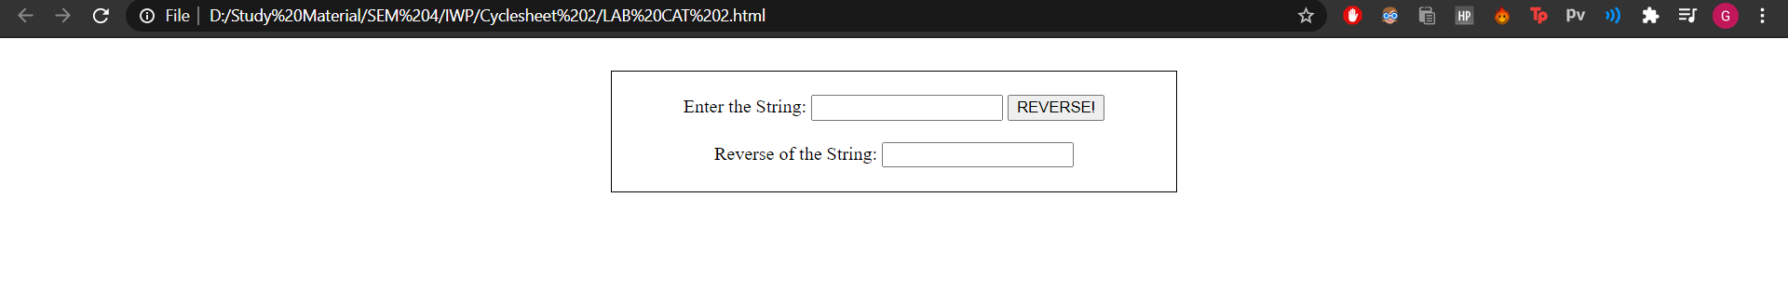

Word input

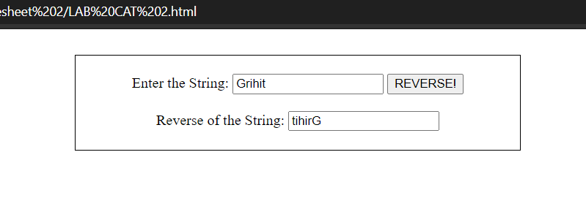

String input

